Bridport Area Neighbourhood Plan

Town Centre Car Parks Survey

Introduction and context

This note forms part of the evidence base produced by the Economy Working Group of the Bridport Area Neighbourhood Plan. It primarily reports the results of a survey of town centre car parks conducted to measure their level of use, especially at peak times. It also draws upon two other data sources.

The context for this work is policy ECON4 in the West Dorset, Weymouth & Portland Local Plan 2011-31. This extends the town centre boundary in Bridport in order to permit new retail development on two car parks, namely Rope Walks car park which is a town centre site behind Waitrose and Bus Station car park which is an edge-of-town centre site on the western side. These two car parks have a capacity for 158 vehicles and 92 vehicles respectively. The latter, as its name suggests, also contains the town’s bus and coach station. Whilst ECON4 seeks to ensure that not all this car park space is lost, it refers only to retaining “an appropriate amount”.

The proposal to allow building on these car parks has caused considerable local disquiet. Indeed, there was a petition handed to West Dorset District Council shortly before the Local Plan was adopted, which gained roughly 1,000 signatures. Bridport is a busy market town (and the main settlement in the west of the District) which draws in shoppers and visitors from its hinterland, as well as tourists who are staying over in the area. Public transport options are few (and declining), so inevitably many people arrive by private car. The viability of the town centre and its retail businesses are therefore seen widely as being dependent on having sufficient car parking. In short, local experience of car parking is enough to know that this is an issue worth exploring further through the neighbourhood plan.

Methodology

Two earlier surveys provide useful background evidence. First, is the 2015 survey undertaken to inform the setting of Neighbourhood Plan objectives, where roughly half of respondents considered that parking and traffic flow were either inadequate (18%) or poor (32%), whilst only 10% considered it to be either good or excellent. Second, is evidence gathered for the Bridport Coastal Community Team economic plan, where a consultation identified that lack of car parking was considered one of the area’s weaknesses and a survey found a large majority of respondents saying there were too few car parking spaces.

The car park survey comprised visits to the six key main parks serving the town centre of Bridport. These were carried out on 27th February 2016, on 4th June 2016 and on 9th July 2016. These dates were Saturdays, which is the prime concern, being the town’s main market day and so crucial to retailers and traders. All of these visits were made between 9.30 am and 11.00 am.

Results from the three car park visits are tabulated below.

- Car park usage on 27th February 2016
Car park | Total number of spaces | Number of free spaces found | Vehicles queuing for a space
East Street short stay | 64 | 3 (see footnote) | 6
East Street long stay | 79 | 0 | 2
Wykes Court | 96 | 0 | 8
South Street | 98 | 1 (see footnote) | 5
Rope Walks | 158 | 6 | 3
De Savary | 22 | 1 | 0
Totals | 517 | 11 | 24
Footnote: the vacant spaces at these two car parks were either disabled spaces or electric vehicle spaces.

- Car park usage on 4th June 2016
Car park | Total number of spaces | Number of free spaces found | Vehicles queuing for a space
East Street short stay | 64 | 0 | 2
East Street long stay | 79 | 0 | 2
Wykes Court | 96 | 0 | 0
South Street | 98 | 0 | 0
Rope Walks | 158 | 0 | 3
De Savary | 22 | 1 | 0
Totals | 517 | 1 | 7

- Car park usage on 9th July 2016
Car park | Total number of spaces | Number of free spaces found | Vehicles queuing for a space
East Street short stay | 64 | 0 | 5
East Street long stay | 79 | 0 | 2
Wykes Court | 96 | 0 | 3
South Street | 98 | 0 | 0
Rope Walks | 158 | 0 | 6
De Savary | 22 | 0 | 1
Totals | 517 | 0 | 17

Whilst not surveyed, anecdotal evidence is that some of the town centre car parks are also heavily used on certain evenings, especially when events are taking place at the Arts Centre and/or Electric Palace.

Data about the number of tickets purchased at ticket machines between October 2015 and September 2016 has kindly been provided by West Dorset District Council, who own and manage these car parks. Whilst of interest, the obvious issue with this data is that it excludes those who park with a season ticket or a shoppers permit and hence don’t need to purchase a ticket. Permit holders appear to be a substantive proportion of those who park regularly in town. The data is therefore of more use for looking at patterns of parking at different times and on different days.

It confirms that most tickets are purchased on a Saturday and especially during the morning (9.00 am to 1.00 pm). However, ticket sales can also be quite high on other weekdays, particularly on Wednesday morning which is the mid-week market day. Machines at the short-stay Rope Walks car park typically sell between 400 and 650 tickets on a weekday, with between 600 and 700 tickets sold on a Saturday. The fact that 700 tickets or just over seems to be a ceiling may indicate that this is the maximum capacity if the car park is close to full through the day. Machines at the long-stay Bus Station car park typically sell between 40 and 90 tickets on a weekday, with between 90 and 175 sold on a Saturday. Numbers parking instead with a permit are unknown. The higher ticket numbers for Rope Walks than for Bus Station car park are likely due to:
- Rope Walks having more capacity i.e. 66 more parking spaces;
- Rope Walks being short stay, whilst Bus Station is long stay; and
- Rope Walks serving Waitrose, being within supermarket trolley pushing distance.

It is noted that redevelopment plans for St Michael’s trading estate will mean a loss of areas currently used for (free) car parking. Some of the displaced vehicles may well move to the adjacent Bus Station car park.

Findings

The main findings from this work are as follows:

- Local opinion from surveys is that the area currently has too few car parking spaces.
- The survey finds that at peak times (Saturday mornings) there are very few, if any, vacant spaces to be found in town centre car parks.
- The survey also finds that at peak times (Saturday mornings) there are often cars looking for spaces and that queues may outnumber vacant spaces.

Conclusions

The findings of this survey confirm that demand for town centre parking is high at peak times and there is no excess capacity in car parks. Indeed, it finds more cars trying to enter the surveyed car parks than there are vacant spaces, with queues forming in some cases.

This mirrors the widespread experience of local people on a typical Saturday morning and especially on a Saturday morning in Summer months, when spaces are known to be hard to find from about 9.30 am onwards. It also mirrors the experience relayed by local shops, that some customers have spent time driving round town searching for a space. This can add to traffic congestion and may dissuade shoppers or visitors from returning.

There is a strong case for protecting the car park provision that exists at Bridport. If anything it would appear to be under-supplied. Any loss of car park capacity could have an adverse effect on the town centre viability.

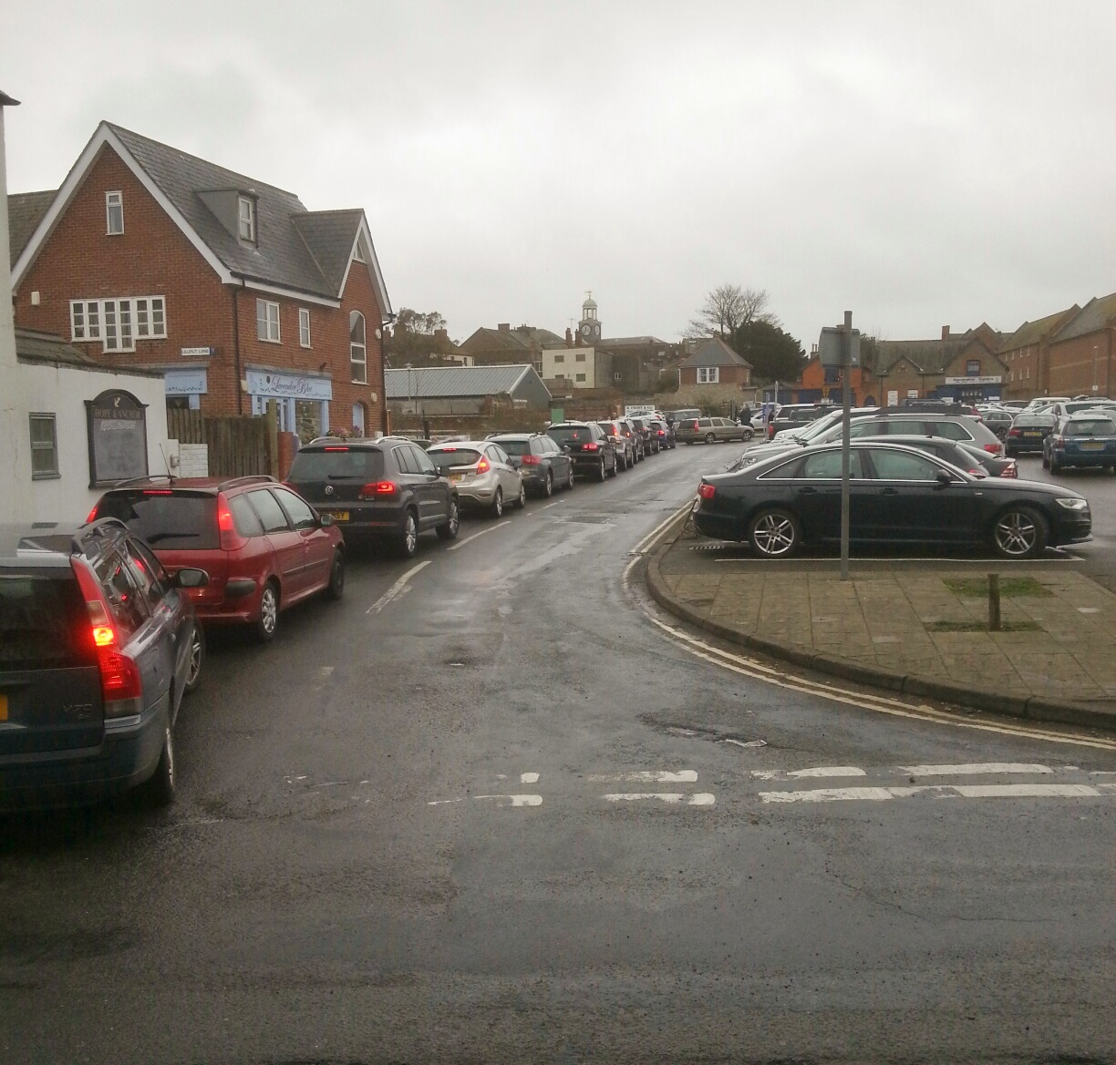
Cars queuing to enter Rope Walks car park on a particularly busy Saturday

Caroline Meredith and Brian Wilson
BANP Economy Working Group
Version: February 2017

