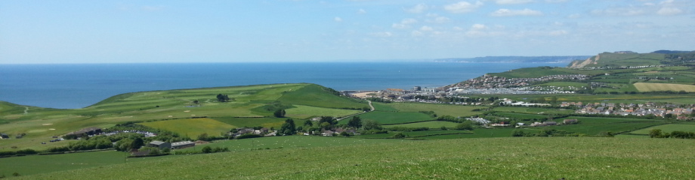

Vision and Objectives

Consultation Summary

Vision 2030 – Neighbourhood Plan for Allington, Bothenhampton and Walditch, Bradpole, Bridport and Symondsbury QUESTIONNAIRE SUMMER 2015

Consultation report produced October 2015

Contents:
Why we have produced this summary 1
The consultation stage 1
How we consulted 1
Who responded 1
Priorities 1
Possible focus areas 2
The Vision and Objectives 3
Conclusions and next steps 4
Appendix A: Questionnaire 7
Appendix B: QuestionnaireComments 8

Why we have produced this summary
This is a record of the consultation that was carried out during Summer 2015, and how it helped us prepare the Neighbourhood Plan. It will form part of the evidence base for the plan, detailing how we consulted, the main issues and concerns that people raised, and how these concerns and issues have been considered.

The consultation stage
In preparing the neighbourhood plan we had a number of consultation stages. The Summer 2015 consultation focused on the vision and objectives for the plan, following the Launch event that was held in Autumn 2014.
Further consultations will be held as work progresses on the Neighbourhood Plan

How we consulted
The Summer 2015 consultation ran for more than 12 weeks from 30 May to 1 September 2015. The questionnaire was available online at the Vision2030 web site with hard copies at the Town Council offices at Mountfield, the Tourist Information Centre, Bridport Library and at the Leisure Centre. Steering Group representatives and the Neighbourhood Plan display were at a number of events over the summer. This included:
- Bradpole Fete 30 May
- Walditch Village Hall 6 June
- Bridport Food Festival 13 June
- Allington Hillbillies Fete 21 June
- Charter Fair 4 July
- Bothenhampton Church Picnic 18 July
- Bucky Doo Square 8 August
- Melplash Show 27 August
- Symondsbury Fete 30 August

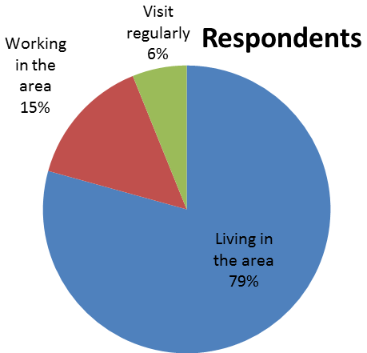
Who responded
Some 343 questionnaire responses were received, primarily from local residents, but also including those that either work or visit the area but did not live locally.

Priorities
Respondents were asked to rate a range of features for the area, to help the Steering Group gauge what may need to be focus of future change.

The feedback highlighted that possible priorities should be:
- the provision of affordable housing that the community needs
- the provision of job opportunities through new or expanded businesses (which would include tourism)
- improved transport infrastructure
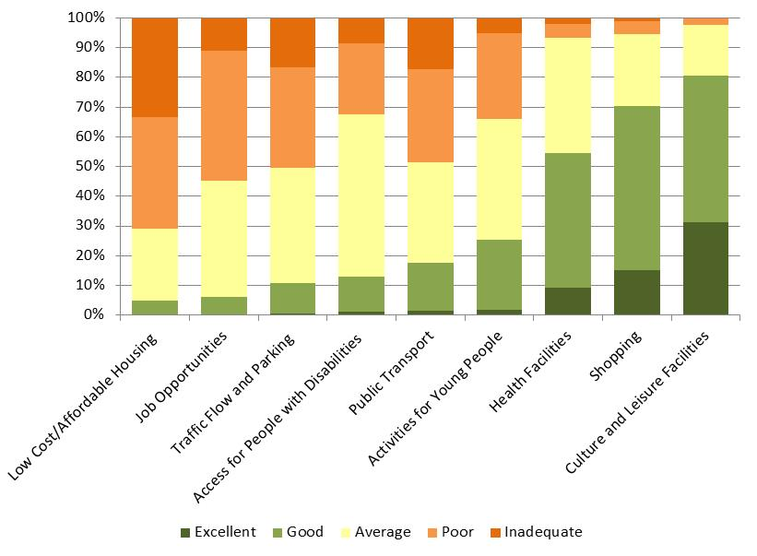
It was also clear that there would be considerable support for maintaining what are considered very good community facilities (healthcare, shops, culture and leisure).

Possible focus areas
The questionnaire also asked people to consider and suggest possible areas for development (housing, employment etc.) or areas for protection, as well as opportunities and threats.
The most common response in terms of areas for protection was green spaces (46 responses). This included
- Local recreational trails and rights of way
- Askers Meadow, Watton Hill and other green areas within the A35 on the edge of Bridport
- Journeys End, Skilling
- Jelly Fields nature reserve and the green gap between Bridport and Walditch village
- Green fields between Lake Lane and Bothenhampton village
- Green spaces in Bradpole such as Gore Cross, Pageants Close play area, the green area on Wellfields Drive and the fields between Happy Island and Jessop Avenue
- Allington Hill
- Conegar Hill
- All existing play areas and parks
- The community orchard
The need for employment sites were suggested (37 as possible development responses, and 40 as opportunities), with many (19) commenting specifically on the future of St Michael’s Estate for small business units, and tourism (20)
Local affordable housing was also a common suggestion (29 responses), with some specific sites mentioned including Vearse Farm, land behind the CAB where the salt etc is deposited, the Mountjoy School site, and the old Magistrates Court
There were a diverse range of ideas, with many linked to making the most of the specific character and heritage of the area, through to more eco/green ideas, and more general ideas such as better shops, parking and employment base.
The main concern (in terms of threats) linked to possible over-development (with a number of comments specifically mentioning Vearse Farm) but this was set against concerns of housing and employment availability. The loss of young people, due to them leaving the area because of limited opportunities, was also a general theme arising from the comments. Traffic and parking problems was another common theme, along with losing the character of the town as it grows further.

The Vision and Objectives
The proposed vision and draft objectives were tested as part of the consultation. These were:
Our vision takes us to 2030 and is ambitious and demanding. The neighbourhood plan will help us as a community to develop the area and its surrounding parishes as a place that people want to live in; where there is economic and educational opportunity and our community is inclusive, dynamic and successful.
Our objectives
- To maintain, protect and enhance the unique nature, heritage, important features, character and assets of the Neighbourhood Plan Area, including the independent nature and vitality of the town centre.
- To enhance and protect our AONB status, the conservation areas and the Jurassic Coast.
- Encourage sustainable tourism which uses local services, facilities and locally produced goods creating an accessible and attractive destination for visitors and local people. This will further our AONB status.
- To protect and develop key services and facilities in sustainable rural areas.
- To encourage the development of increased facilities including education, health, leisure, cultural and community services where these bring benefits to our community in line with this devolved Plan.
- To provide housing that the community needs, of high quality, accessible to services and affordable, in appropriate locations.
- To facilitate the expansion of the local economy to extend opportunity for established local businesses and the creation of new ones, ensuring that our economy is robust with high quality jobs and skills.
- To have excellent leisure, cultural and sporting opportunities, which are accessible to all.
- To alleviate the impact of climate change, develop renewable energy and encourage efficient waste management.
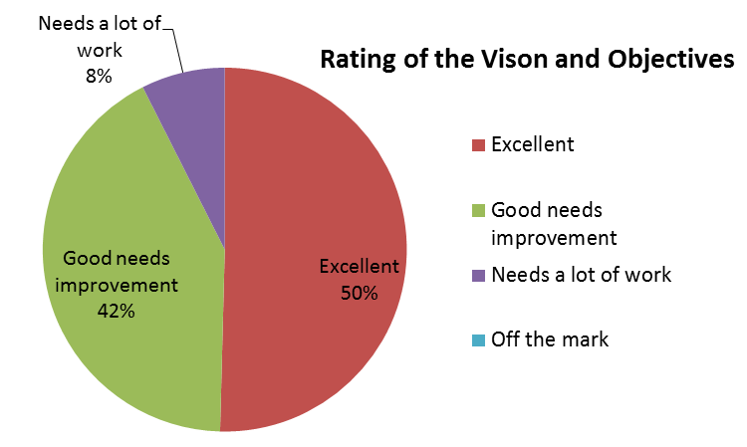
In general most people (over 90%) said that the vision and objectives were good or excellent. Some people pointed out that some elements were a bit vague and some may conflict (such as increasing visitor numbers impacting on the environment). Having more local control and say was mentioned in a number of comments. A number of comments centred around whether the Neighbourhood Plan could deliver against those objectives, giving possible funding and other limitations.
A number of respondents referred to improved transport such as bus services as a missing element

Conclusions and next steps
The consultation helped raise awareness of the work being progressed on the Neighbourhood Plan and to check that the vision and objectives were broadly right.
The responses highlighted the potential need for a specific objective relating to sustainable transport. Although the Neighbourhood Plan cannot deal with all transport matters as many do not require planning permission, it can help deliver projects that may be routed through development sites, or potentially funded from the community infrastructure levy on new development.
There have been some minor changes to more closely align the objectives with the themes being used to guide the work on the plan (such as moving the town centre ‘objective’ to sit within the economic-based objectives), and reduce those elements that cannot readily be delivered through the Neighbourhood Plan.
The objectives have therefore been amended to the following
Theme | Objectives | Revised / new objective
ENVIRONMENT AND HERITAGE | To enhance and protect our AONB status, the conservation areas and the Jurassic Coast.  To maintain, protect and enhance the unique nature, heritage, important features, character and assets of the Neighbourhood Plan Area, including the independent nature and vitality of the town centre. | No change proposed.  To maintain, protect and enhance the unique nature, heritage, important features, character and environmental assets of the Neighbourhood Plan Area.
CLIMATE CHANGE | To alleviate the impact of climate change, develop renewable energy and encourage efficient waste management. | To alleviate the impact of climate change, and minimise our own contribution to climate change, by developing renewable energy and encouraging efficient energy and resource use.
HOUSING | To provide housing that the community needs, of high quality, accessible to services and affordable, in appropriate locations. | To help ensure the provision of housing that the community needs, that is affordable and accessible to services, in appropriate locations and of good design.
LOCAL ECONOMY  EMPLOYMENT AND RETAIL AND TOURISM | To facilitate the expansion of the local economy to extend opportunity for established local businesses and the creation of new ones, ensuring that our economy is robust with high quality jobs and skills.  Encourage sustainable tourism which uses local services, facilities and locally produced goods creating an accessible and attractive destination for visitors and local people. This will further our AONB status. | To facilitate the expansion of the local economy, extending opportunities for established local and for new businesses, ensuring that our economy is robust with high quality jobs and skills.  To maintain, protect and enhance the independent nature and vitality of our town centre.  To encourage sustainable tourism which uses local services, facilities and locally produced goods, creating an accessible and attractive destination for visitors and local people.
COMMUNITY FACILITIES  SERVICES, EDUCATION AND CULTURAL FACILITIES | To encourage the development of increased facilities including education, health, leisure, cultural and community services where these bring benefits to our community in line with this devolved Plan.  To have excellent leisure, cultural and sporting opportunities, which are accessible to all.  To protect and develop key services and facilities in sustainable rural areas. | To protect our excellent community facilities including education, health, cultural, sport and leisure facilities. To increase their range and availability where these bring benefits to our community. To make sure that these facilities are accessible to all, including those living in the more rural parts of the plan area.
SUSTAINABLE TRANSPORT | No draft objective | To identify and promote alternative methods of transport to the motor car, which improve access for local residents and visitors to local services around the town and adjoining parishes, and keep Bridport and surrounding parishes uncongested.
LAND USES AND LOCATIONS | No draft objective | To ensure that sites that are needed for different land uses are selected to best meet the range of local needs identified in the Plan, and designed in keeping with the local character of that area.
As part of the consultation people were given the opportunity to volunteer to be part of working groups to take forward work on the various themes. The working groups will be launched in the coming month, with tasks linked to the delivery of the above objectives.

Appendix A: Questionnaire
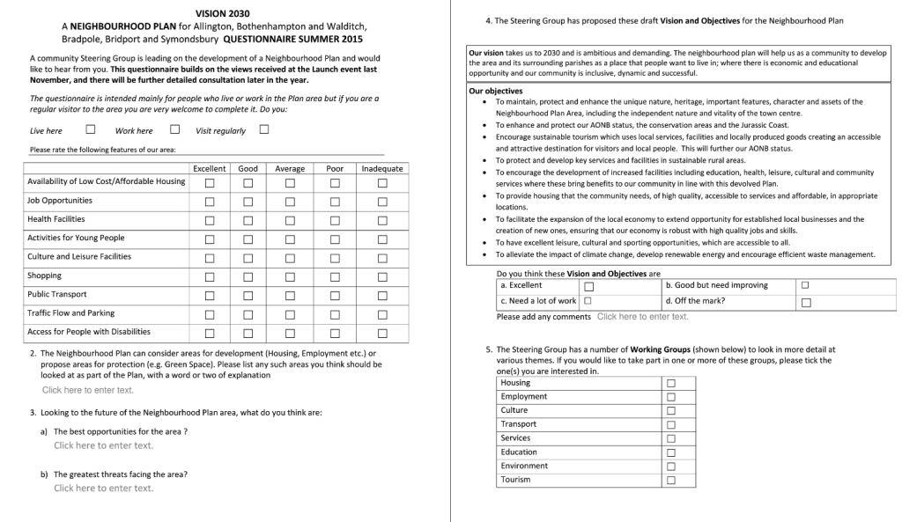

Appendix B: Questionnaire Comments

Q2 Proposed areas for development.
Footpath to and from Walditch from the Hyde.
More cycle paths.
St Michael’s Estate small business units being available.
Vearse Farm – low cost housing for locals.
Sensible housing growth over a controlled time period.
Protect green spaces from building and parking.
Affordable housing for local and young families.
Protect Walditch village keep it separate from Bridport.
Affordable housing but this needs to be restricted.
Develop rewarding and career building job opportunities.
Jelly Fields nature reserve and surrounding countryside to Crock Lane needs to be preserved.
Green spaces to be kept and preserved where possible.
Open spaces in the neighbouring parishes should be protected.
Stop over development, restrict the size and protect the land.
Maintain and enhance AONB.
Create places for young people instead of second homes.
Vearse Farm provide appropriate infrastructure, services and correct drainage.
Protect countryside developments these should not extend past boundary lines.
Area for protection AONB from A35 to Bridport.
Protect St Michael’s Trading Estate.
Protect surrounding countryside especially the hill in Walditch.
Walditch needs a kerb cleaner.
Housing only on brown areas.
The car parks in West Bay need resurfacing with marked bays.
Protect the fields between Happy Island and Jessop Avenue, enjoyed by locals, very much valued and must be kept for future generations.
Protect green spaces and have nature in mind when fields are intended for development.
Keep the buses from Bradpole to Bridport these are highly valued by locals.
Protect green spaces in Bradpole such as Gore Cross, Pageants Close play area and Happy Island.
Full usage of unoccupied property for private and social housing and discourage second homes.
Limited amount of small houses needed.
Asker Meadow and West Bay need protecting.
Green spaces are limited these need increasing.
Need for employment.
Protect green spaces and the quality of life.
Housing for people and homeless families.
Complete the bike track to Maiden Newton.
Low cost units for start up businesses.
Increase affordable houses for families.
The need for more allotments.
Un-occupied and derelict properties left to local community.
Protection of Happy Island very important to residents.
Better access to green areas.
No development on floor plain areas.
Housing in small sites.
Protect play areas.
Don’t build on floodplains this leads to an increase of flooded areas.
Issue with dog fouling in green spaces where children play for example Happy Island.
St Michaels Trading Estate retain for employment.
Jobs and affordable housing to keep young people in the area.
Adequate parking particulars in the summer.
More toilet facilities.
Protect Watton Hill for future generations.
To make use of empty buildings even as temporary usage.
Larger companies in the area for employment purposes.
By-pass for Chideock, traffic flow through the summer needs to be decreased.
By-pass would benefit the whole area.
Improved infrastructure for increase on population and visitors – wards, carparks, health system, activities and opportunities for young people.
Public transport links need alternatives to ease private car use.
Brown field sites used for housing and protect green spaces.
Rope Walk car park kept for parking.
Wider range of leisure activities for younger generations instead of travelling to Weymouth and further.
Journeys End, Skilling should be a protected green area.
The relationship between housing needs, cultural, social and environmental priorities are crucial.
Protect areas that bring in tourists and conserve the landscape.
Low cost housing with adjacent local employment.
Improve bus services and public transport.
Public transport to cope with elderly and increased population.
Housing development and environmental implications.
Protect independent retailers.
Vearse Farm development.
St Michael’s Trading Estate must be kept but modernised.
Retain flood plains.
Affordable housing for people to buy.
Outdoor activity space for children.
Increased broadband.
Helping new businesses develop or start.
Need to attract more employers to the area and more business premises.
Improve transport lines to the area the A35 needs improving.
Build houses big enough to house larger families.
Create incentives for all businesses to offer apprenticeships.
Extend the educational facilities to university level by returning the Science and Literacy Institute to its true intended purpose.
More park facilities and youth clubs for younger people.
Watton Hill designated green space the site is a key archaeological site visible from all areas of the town.
Watton Hill recreations space for walking links new foot paths with Coneygar hill and a footpath route from Colfox to the town.
Green areas should be protected and brown field sites used as priority. The natural setting and status of the countryside gives the town its character.
Visitors and residents should chose Bridport area for its stunning natural scenery.
Vearse Farm have people thought of the extra burden on local amenities such as doctors, dentist’s, schools and parking.
Development of St Michaels’ trading estate and expanding the antique and arts trades.
Green spaces to be managed sensitively and not over tidied.
Traffic flow would improve if Downes Street could be left turn only at the junction with East Street.
The green fields between Lake Lane and Bothenhampton village are part of the green lanes for nature which surround Bridport.
Housing and environment too much development has been allowed around the villages of Bothenhampton, Walditch and Bradpole to retain their character.
Protection of green spaces – Askers Meadow, Happy Island fields, Allington Hill all these spaces if lost will have harm to wildlife and people’s health and well being. Do not build on them we need places to walk and keep healthy and wildlife.
Keep existing play areas and parks.
Increase solar power onto public buildings.
Redundant old buildings unused space in the town.
Bothenhampton should be protected or it’ll lose its unique character.
Provision for green spaces providing conditions for wildlife to move freely from area to area should be included in any plan.
Morrison’s carpark for multi-storey car park.
St Michael’s trading estate for employment not housing.
Pedestrian zone – Gundry lane to the traffic lights.
St Michaels has wonderful potential for workshops with residency for young people but not a massive commercial enterprise.

Q3a The best opportunities for the area.
Preserve green spaces.
Build apartment blocks with shared facilities such as laundry rooms, heating and parking.
Care home and, voluntary work to replace state/local government activity.
Encouragement for street market and Bucky Doo Square.
Expanding local economy based on businesses and industries, appropriate for a small town.
To maintain its identity making it a wonderful rural place to live.
Tourism.
Improvements to housing and traffic.
Higher development hub to be developed branch from neighbouring colleges such as Weymouth and Bournemouth University.
ANOB and education.
Improve opportunities for young people.
The beautiful countryside.
Increasing tourism, creating jobs and the number of enterprises.
To continue to develop as an artistic and cultural town.
Maintain the towns’ architecture.
To develop Bridport cultural scene.
To extend historic rope related industries.
Develop small business employers and build on artistic reputation of Bridport.
Encourage attention to dangerous trees.
Protect the green areas and build only on brown land.
Better public transport to bring visitors into the area.
Encourage green tourism, protect the natural habitat and access to it for the benefit of local people and wildlife.
There are places to the north of Bridport that could go for cheap homes.
Growth in local food and culture already strong in the area.
Full use of tourism and natural assets for example open trails.
Promotion of the area as the number one tourist destination.
The need for better shops.
Keep the local people.
Tourism to an unspoilt area of the country.
Strong community local hub and services.
Free shoppers parking.
For all groups to work together to achieve set goals.
Protection of the market town and landscape to sustain tourism.
Park areas, car parking, music and art.
Activities for families and young adults.
Area becoming known for quality tourism and food production.
Must retain our market town.
Social annual activities all year round.
Invest in youth try to keep and attract young people to the area.
Increase number in local food producers.
Locally sourced food and renewable energy.
The area is highly attractive to people approaching retirement with good income streams and capital.
Need more opportunities for younger generation.
More office space to attract visitors.
Local manufacturing skills.
Protect existing assets that Bridport has to offer.
Careful development of ex-industrial sites and buildings.
Main route to Cornwall.
Great opportunities for music, art and culture.
Exploit the culture centres i.e. Arts centre and Electric Palace, these have a good reputation that needs exploiting.
Focus of what makes Bridport special – street markets, events and coastline.
Develop co-housing in Hospital lane.
Sustain eco systems.
Digital economy.
Bigger shops.
Great amount of local well supported small businesses.
Small scale industry and services.
Taking care of the amazing area we already have.
Already a vibrant town needs the atmosphere kept.
Guide heavy traffic away from the town.
Developing Bridport into a more modern and attractive town whilst capturing its past. Modern and old working in conjunction.
Taking care of peoples well being and health in a healthy environment.
Tourism however its seasonal nature causes problems.
The already existing businesses and trades opening up to their full potential for future employment.
To build on existing strengths in cultural, leisure and natural environment.
To keep our local community hospital and its services, build on the services it currently has people who cannot travel miles for a hospital.
Good local food and friendly environment.
More public transport to enable these without transport to get to work.
St Michaels trading estate for thriving, inspiring small independent business and work spaces. Also include leisure activities, community workshops etc.
Real co-housing socially inclusive, affordable and sustainable.
Making it possible for the younger generation to live here.

Q3b The greatest threats facing the area.
Build spacious apartments instead of multiple small houses.
A35 traffic around Bridport and the surrounding areas.
Need a ‘walk in’ medical centre with reasonable charges.
Lack of training opportunities and businesses.
More infirm residents.
Housing availability too few young workers and families.
Increased traffic.
Loss of public toilets.
Struggle to attract doctors and dentists.
Over development making the area less unique.
Over development of housing without sufficient infrastructure.
The absence of employment opportunities.
Increase of traffic on A35 and using Walditch village as a main road.
Too many houses are holiday homes.
Ageing population.
Loss of protected environmental areas.
Second homes.
Insufficient methods to reduce speeds especially on A35 and Walditch need speed restrictions.
Young people cannot afford to stay in the area so move away.
Imbalance between young and old.
Parking is detreating.
Losing Bridport’s distinctiveness as development grows.
New housing estates will overwhelm the market town.
West Dorset County Council.
Lack of listening to local people.
An influx of new residents who can afford to pay high prices, losing homes for locals.
Development that benefits the developer at the expense of community interests.
Overdevelopment especially towards the coast. Lack of employment and wages which prevent people to live and stay here.
Lack of affordable rented housing.
Building on flood plans consideration needs to be given before any further development.
Drainage systems causing flood in Bradpole and other areas.
No footpaths in Bradpole i.e. Lee Lane, St Andrews Road, Higher Street, making walking dangerous.
Building and not updating infrastructure for example sewage systems and drainage.
With the present hospital, schools and social care a higher population with overload these.
Lack of local and variety of shops.
Harmful substances for example drugs.
Helping the homeless.
Low paid jobs.
Peoples’ attitude to young people and families.
Poor public transport and car parking.
No facilities for younger people to keep them interested in staying in the area.
Young people having to move out of the area for housing and jobs.
Overdevelopment and lack of schools.
Low wages and unemployment.
Increase in traffic, shop closures and lack of housing.
The threat to St Michael’s Trading Estate should be used for artisan workshops, studios and low cost units for rent.
Lack of employment and high housing prices means young people we lose out and the town will be taken over by wealthy incomers.
Bad parking and machines will turn people away.
Concentration on the needs of the retired without considering how this can be supported without a younger working population.
Caravan parks covering the countryside.
Local hospitals.
Payment for car parks.
Huge wheelie bins and waste on the pavements.
Set a positive example always obtaining ANOB.
Too much reliance on tourism.
Government cut backs.
Car parks being built on in the future although still needed for parking.
Greedy people who make decisions not listening to local community.
Vearse Farm too much housing in one area and too quickly need a small number with a high proportion of affordable housing.
Lack of peace through an increase in noise.
Over commercialised.
Coastal erosion.
Make people pay higher rates for empty homes.
Vandals and young people having more things to keep them occupied.
Over population.
A government that puts money before people’s well-being.
Diminishing number of younger people.
Lack of independent shops and rates to high.
Lack of good transport links and cut to Dorchester Hospital.
No job opportunities for younger people to stay in the area and build up businesses.
No consideration of schools, transport etc. Use section 106 money to help permanent bus service to Dorchester, Yeovil, and Exeter for people to get to work.
Losing local businesses to big corporations for example supermarkets, these threaten smaller trades.
Threat to the architecture and beauty of the town.
The pressure from local and national government on housing therefore resulting in over development on green spaces.
Expansion of town pressurising local resources, necessity to develop new resources to meet increased demand leading to loss of unique character of the town.
Too much tourism can cause extra traffic pollution, congestion and litter.
Increase in homes leads to property prices forced up, young people cannot afford to buy or rent and are forced out of the area.
Seagull problems, people should not feed them and keep their rubbish out of sight.
The Town and West Dorset District Council.
Town is gridlocked especially on weekend over zealous traffic wardens.
Grids lock every Saturday due lack of parking.
Transport as more bus services are cut then people are isolated in the rural areas outside of town they will sell up and be 2nd homes or holiday homes.
Vearse Farm over development.
Development might be beneficial but detract from rustic character.
Lack of start up employment accommodation.
Over and inappropriate development in West Bay.
Increasing traffic problems not catered for by the current management system.
The decrease in public transport between Bridport and the villages.
Lack of parking driving people away from Bridport.
The infrastructure being unable to cope with large building projects.
Mass Exodus of youth (18-30) – lack of affordable housing and employment opportunities.
London house and rent prices that are excluding a vast amount of people.
Drug trafficking from outside.
Bored and vulnerable youth.

Q4 Comments on the proposed Vision and Objectives
The objectives are obvious we had plans and explanations on how they will be tackled.
Consideration for climate change and population.
Threats to agricultural sustainability and smaller government risk factors during 2020’s.
All very worthy but some require finance which might not be forthcoming.
Tourism can be damaging.
Elevating impact on climate change should be linked to all new housing, build eco-villages.
A good start in the current climate.
There may be some views missing but this is comprehensive.
Excellent but very ambitious.
Good, but a number of these objectives could conflict with each other i.e. No 1 could conflict with number 6.
Objectives are not specific enough.
Point number six needs to be made clear.
Needs to be translated into actions.
The points set out need to be more precise as they are very vague.
The objectives are excellent but have to written in stone.
Playing to the strengths of the areas.
It is important that the parishes have the same consideration as Bridport.
More focus in some areas than others.
Every point is excellent although unsure about the impacts of climate change.
Objectives relating to employment.
The objectives need balancing some out weigh others.
More emphases on the final point, wary of too much development in the area.
Needs a lot of work to make sure the translation i.e. local people come first.
Final objective especially crucial.
Steering group to ensure that parishes are not left out from decision made.
Excellent covers all major points.
Good but needs work.
Good but would question the achievability.
Excellent but how can they be achieved.
Not all objections can be delivered.
The points are well balanced the need for development of the local economy with the desire to maintain the areas unique nature, seems like a challenge.
Good to aim for all the points over time.
Need to focus more on youth and affordable housing.
The points are vague need more detail.
Excellent there is plenty of scope to exploit our wonderful surrounding countryside and its associated wildlife for example we have rare water voles.
Excellent if these objectives are achieved it will make the area one of the best in the country.
Focus more on housing, jobs and renewable energy.
Good but need more information on how these can be achieved.
Excellent great to see combination of interests for family, young people, addressing climate change and sustainable economic development.
The area is becoming a retirement/holiday home.
“The problems we already have are not being addressed – the lack of hospital beds and related services. Squeezing more people into the area with more jobs and housing is making the situation worse. You do not want to be old and sick and to live here” Allington Parish.
The plan will need modifying as time moves on.
Devote more control of the area away from WDDC to the parishes where locals would have more control.
Promote the natural beauty of our coast and historical importance in the county.
Excellent but depends on how far we are willing to go to obtain these objectives, Bridport is a working town not a museum.
Protect heritage but not at the expense of progress.
Needs a lot of work no one would disagree with the objectives, needs to be specifically focused and hard to reach with limited resources.
Excellent recognising and protecting Bridport and the surrounding area’s unique and special character is essential to its future.
Stop wasting time and money and get on with making a difference.
Excellent comprehensive vision to provide housing to the community of high quality and accessibility needs further development.
As long as WDDC and DCC do not interfere.
Excellent but you have to work with WDDC which is the issue.
Keep flexible depending on what the future will bring.
Excellent but no mention of reliable public transport.
All the bullet points sound ideal the reality could be totally different, excellent starting point.
Excellent but only if backed up by careful planning and execution.
The last point regarding climate change should be at the top of the list.
Excellent as long as the council represent the concerns, wishes and proposals of local people.
The Town Council have the authority to decide how these objectives are achieved i.e. over ruling opposing plans made by non-residents, or by DCC or WDDC.

